**IOT CASE STUDY – 1**

Iot – Based Automated

Control Of Computer Labs

**(Using ESP32 and CO2 Sensor)**

Implementation for Review 2 and Review 3:

(Considered for End Semester Lab Component)

Section: CSEA Project Title: Smart Lab

Mentored by: M.Nakkeeran Sir

**Team Members:**

|  |  |
| --- | --- |
| **CB.EN.U4CSE21033** | **Macho Yasho Meghana** |
| **CB.EN.U4CSE21045** | **Praveen N** |
| **CB.EN.U4CSE21047** | **Reshiha RG** |

**Logic of How this Works :**

Our methodology involves collecting data from the laboratory over a span of one month, which equates to four weeks. We are specifically concentrating on three days each week: Monday, Wednesday, and Friday. The data we gather will encompass the count of laboratory sessions held on these days, the energy consumption for each session, the quantity of systems employed during each session, and the measurement of CO2 levels in the lab. This comprehensive data collection will provide us with a holistic view of the laboratory’s operations and environmental impact.

**Implementation of the Logic Proposed and Pushing the values into Influx DB :**

Code for Pushing the data (populated for a week) into InfluxDB :

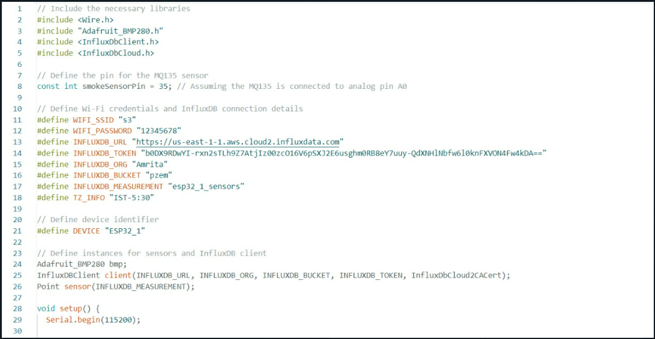

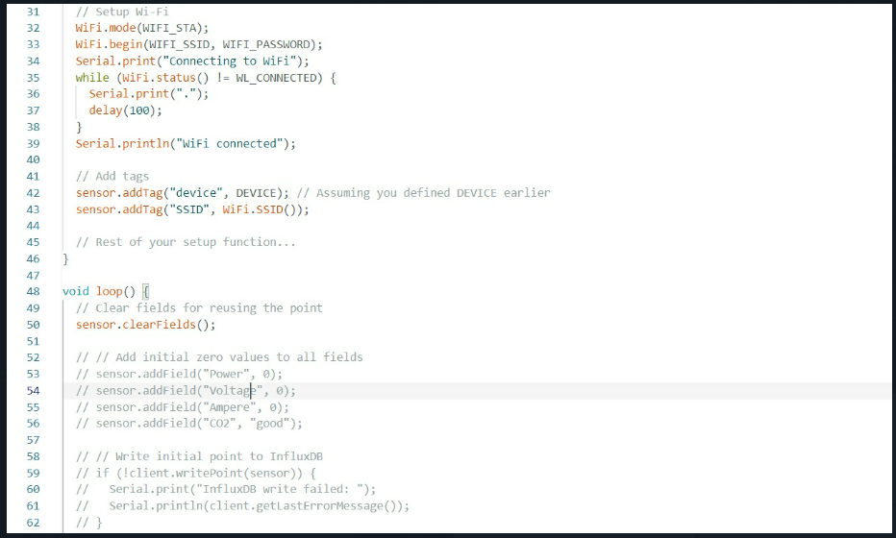

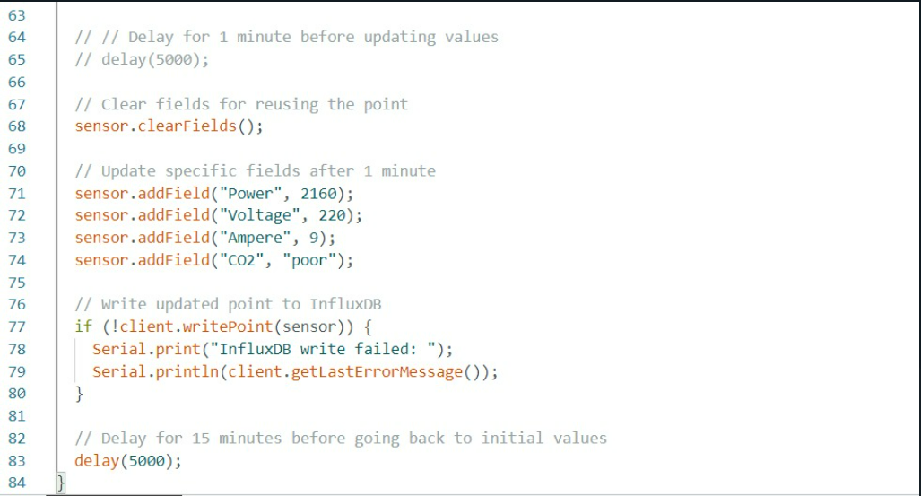

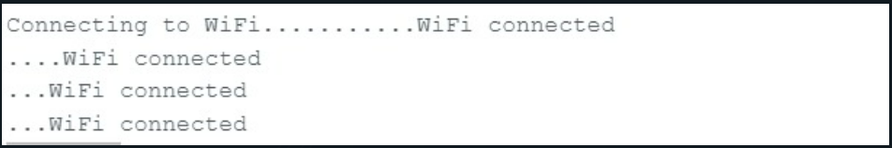

**InfluxDB Analysis and data stored over A week :**

Data that is stored for a week’s time with the Ampere, Power and voltage of the whole laboratory system that is working on Monday(1 slot) , Wednesday(1 slot) and Friday( 2slots).

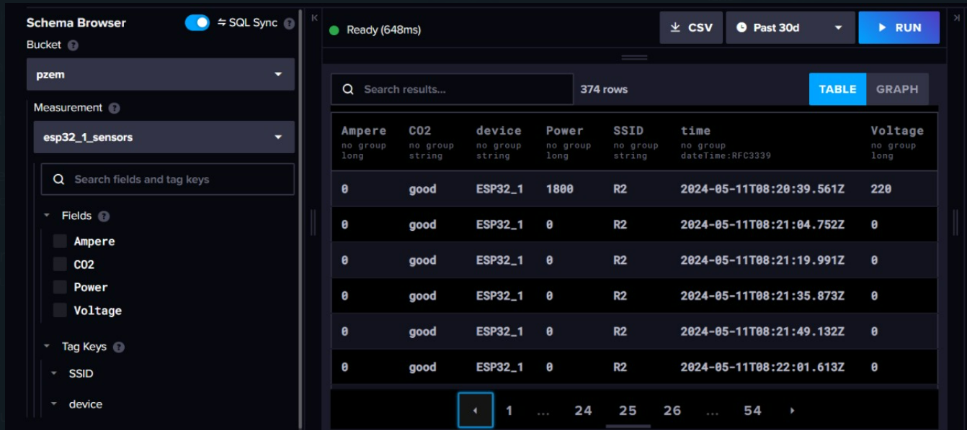

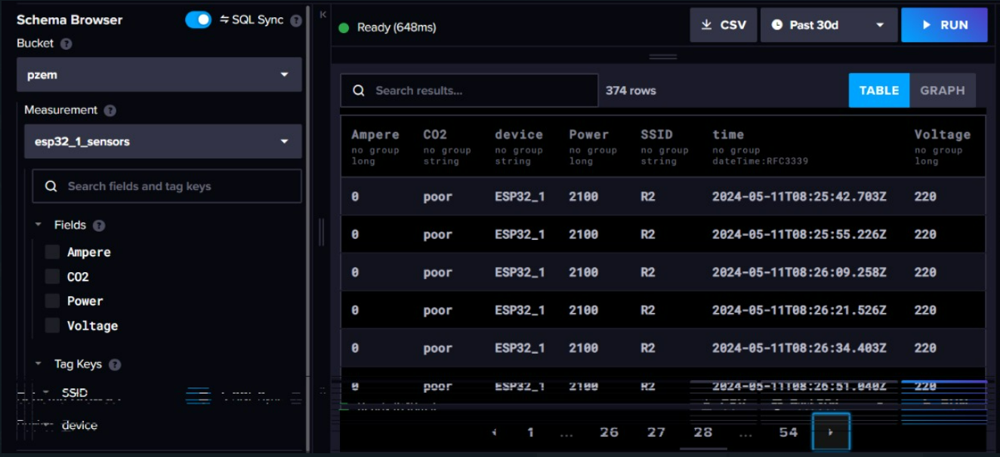

This graph shows the visualization of Ampere values that were stored for a week’s time :

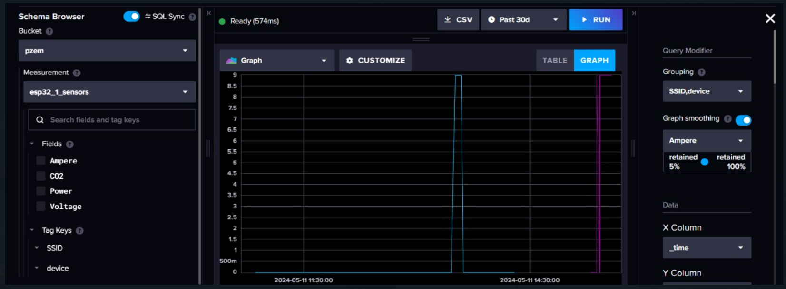

This graph shows the visualization of Power values that were stored for a week’s time :

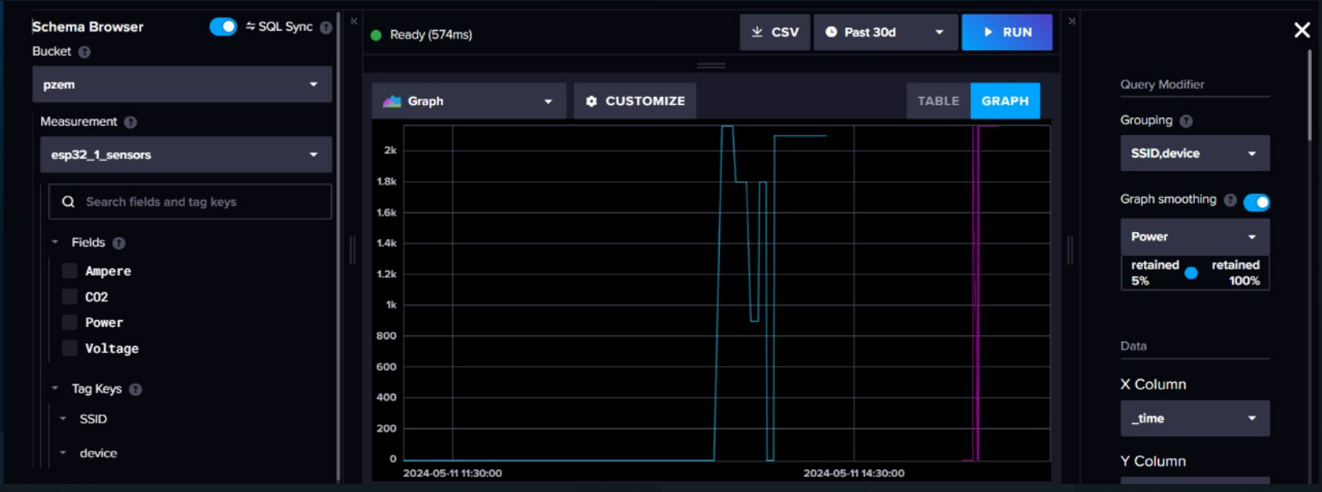

This graph shows the visualization of Voltage values that were stored for a week’s time :

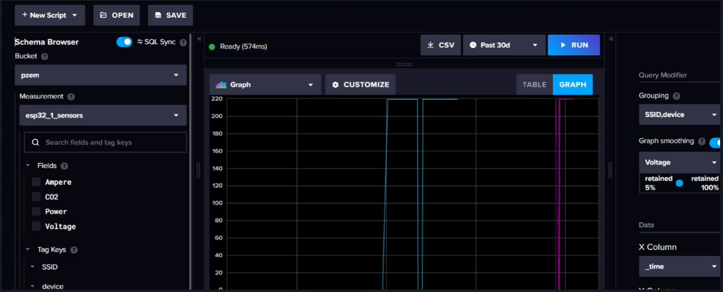

**InfluxDB Analysis of C02 sensor values stored over A week:**

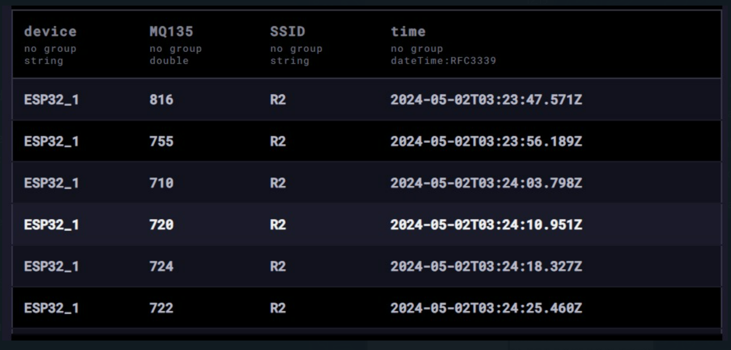

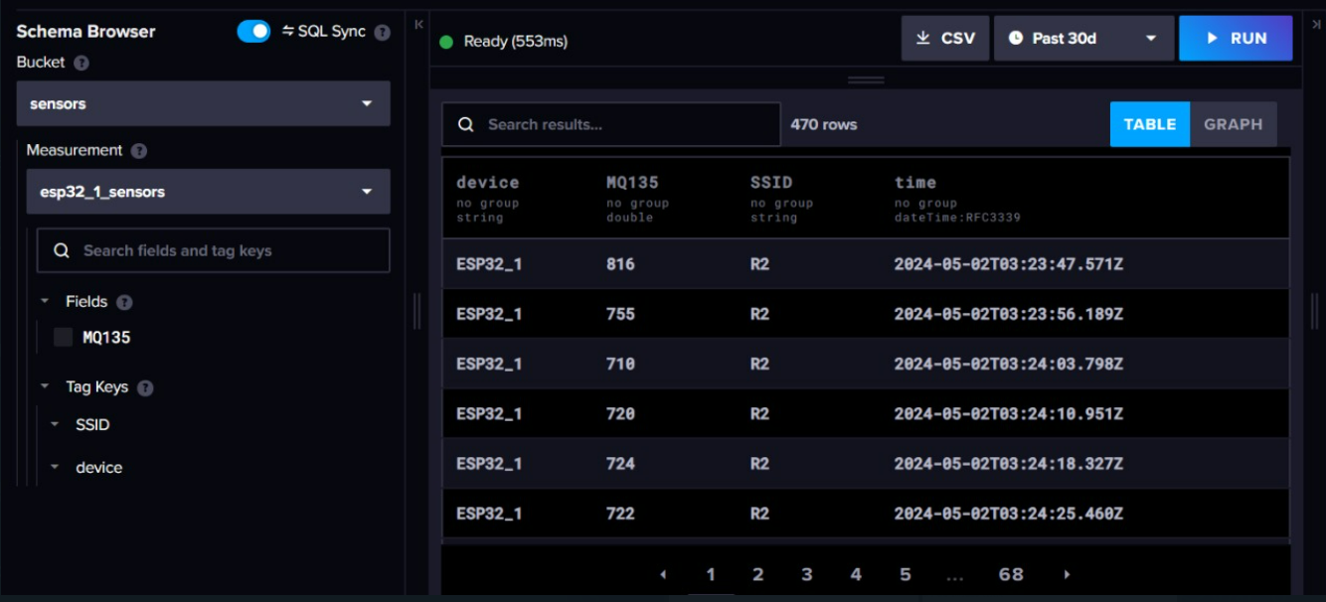

This graph shows the demonstration of the CO2 values :

